SLIDEBAR

Create route

 <li class="treeview">

      <a href="#">

        <i data-feather="message-circle"></i>

        <span>Brands</span>

        <span class="pull-right-container">

          <i class="fa fa-angle-right pull-right"></i>

        </span>

      </a>

      <ul class="treeview-menu">

        <li><a href="{{route('all.brands')}}"><i class="ti-more"></i>All Brands</a></li>

      </ul>

    </li>

WEB ROUTE

Route::get('/all/brands',[BrandController::class,'AllBrands'])->name('all.brands');

CONTROLLER

 public function AllBrands()

    {

*if*(Auth::id())

        {

*return* view('admin.brands.all_brands');

        }

*else*

        {

*return* redirect()->route('login');

        }

    }

MAINTAIN THE VIEW

C:\xampp\htdocs\faisal\resources\views\admin\brands\all_brands.blade.php

MODEL

**Php artisan make:model Brand –m**

   $table->id();

            $table->string('brand_name_en')->nullable();

            $table->string('brand_name_hindi')->nullable();

            $table->string('brand_slud_en')->nullable();

            $table->string('brand_slud_hindi')->nullable();

            $table->string('brand_image')->nullable();

            $table->timestamps();

    protected $guarded = [];

**php artisan serve**

**LOAD TABLE DATA WITH FULL FEATURES**

Find this in the file **table_data.html**

**Maintain code**

@extends('admin.admin_master')

@section('content')

<div class="container-full">

*<!-- Content Header (Page header) -->*

    <div class="content-header">

        <div class="d-flex align-items-center">

            <div class="mr-auto">

                <h3 class="page-title">Data Tables</h3>

                <div class="d-inline-block align-items-center">

                    <nav>

                        <ol class="breadcrumb">

                            <li class="breadcrumb-item"><a href="#"><i class="mdi mdi-home-outline"></i></a></li>

                            <li class="breadcrumb-item" aria-current="page">Tables</li>

                            <li class="breadcrumb-item active" aria-current="page">Data Tables</li>

                        </ol>

                    </nav>

                </div>

            </div>

        </div>

    </div>

*<!-- Main content -->*

    <section class="content">

      <div class="row">

        <div class="col-12">

         <div class="box">

            <div class="box-header with-border">

              <h3 class="box-title">Data Table With Full Features</h3>

            </div>

*<!-- /.box-header -->*

            <div class="box-body">

                <div class="table-responsive">

                  <table id="example1" class="table table-bordered table-striped">

                    <thead>

                        <tr>

                            <th>Name</th>

                            <th>Position</th>

                            <th>Office</th>

                            <th>Age</th>

                            <th>Start date</th>

                            <th>Salary</th>

                        </tr>

                    </thead>

                    <tbody>

                        <tr>

                            <td>Tiger Nixon</td>

                            <td>System Architect</td>

                            <td>Edinburgh</td>

                            <td>61</td>

                            <td>2011/04/25</td>

                            <td>$320,800</td>

                        </tr>

                        <tr>

                            <td>Michael Bruce</td>

                            <td>Javascript Developer</td>

                            <td>Singapore</td>

                            <td>29</td>

                            <td>2011/06/27</td>

                            <td>$183,000</td>

                        </tr>

                    </tbody>

                    <tfoot>

                        <tr>

                            <th>Name</th>

                            <th>Position</th>

                            <th>Office</th>

                            <th>Age</th>

                            <th>Start date</th>

                            <th>Salary</th>

                        </tr>

                    </tfoot>

                  </table>

                </div>

            </div>

*<!-- /.box-body -->*

          </div>

*<!-- /.box -->*

        </div>

*<!-- /.col -->*

      </div>

*<!-- /.row -->*

    </section>

*<!-- /.content -->*

  </div>

@endsection

**Two js/files**

<script src="../assets/vendor_components/datatable/datatables.min.js"></script>

<script src="js/pages/data-table.js"></script>

Copy these files in admin master

C:\xampp\htdocs\faisal\resources\views\admin\brands\all_brands.blade.php

@php

$route = Route::current()->getName();

@endphp

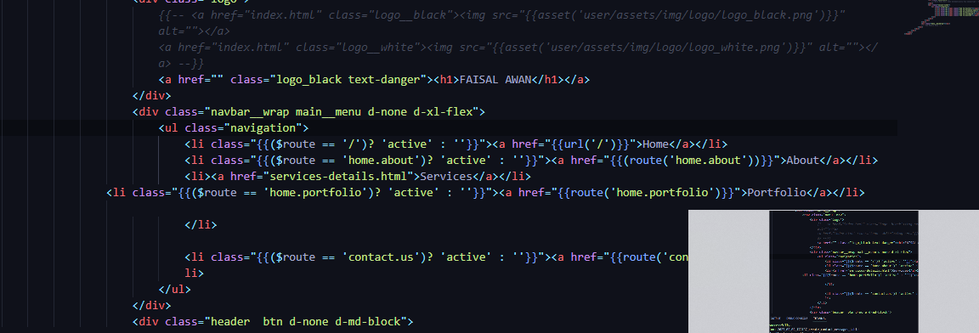

**ADD BRAND**

        <li class="{{($route == 'all.brands') ?  'active' : '' }}"><a href="{{route('all.brands')}}"><i class="ti-more"></i>All Brands</a></li>

Route::get('/all/brands',[BrandController::class,'AllBrands'])->name('all.brands');

C:\xampp\htdocs\faisal\resources\views\admin\brands\all_brands.blade.php

    <form action="{{route('store.brand.data')}}" method="post" enctype="multipart/form-data" >

                    @csrf

ROUTE

Route::post('/store/brand/data',[BrandController::class,'StoreBrand'])->name('store.brand.data');

CONTROLLER

  public function StoreBrand(Request $request)

    {

*//validation*

          $request->validate(

            [

                'brand_name_en' => 'required',

                'brand_name_hindi' => 'required',

                'brand_image' => 'required',

            ],

            [

                'brand_name_en.required' => 'Brand English name is required',

                'brand_name_hindi.required' => 'Brand hindi name is required',

            ]

        );

        $image = $request->file('brand_image');

        $name_gen = hexdec(uniqid()).'.'.$image->getClientOriginalExtension();  *// 3434343443.jpg*

        Image::make($image)->resize(300,300)->save('upload/brands/'.$name_gen);

        $save_url = 'upload/brands/'.$name_gen;

        Brand::insert([

            'brand_name_en' => $request->brand_name_en,

            'brand_name_hindi' => $request->brand_name_hindi,

            'brand_slud_en' => strtolower(str_replace('','-',$request->brand_name_en)),

            'brand_slud_hindi' => strtolower(str_replace('','-',$request->brand_name_hindi)),

            'brand_image' => $save_url,

            'created_at' => Carbon::now(),

        ]);

        $notification = array(

        'message' => 'Brand Data Inserted Successfully',

        'alert-type' => 'success'

    );

*return* redirect()->back()->with($notification);

    }

EDIT

                                <a href="{{route('edit.brand')}}" class="btn btn-sm  btn-outline bg-info">Edit</a>

Route

Route::get('/edit/brand/{id}',[BrandController::class,'EditBrand'])->name('edit.brand');

Controller

   public function EditBrand($id)

    {

        $brand = Brand::findOrFail($id);

*return* view('admin.brands.brand_edit',compact('brand'));

    }

Maintain the view

C:\xampp\htdocs\faisal\resources\views\admin\brands\brand_edit.blade.php

Form route

                <form action="{{route('update.brand',$brand->id)}}" method="post" enctype="multipart/form-data" >

Route

Route::post('/update/brand/{id}',[BrandController::class,'UpdateBrand'])->name('update.brand');

Controller

public function UpdateBrand(Request $request,$id)

    {

        $brand = Brand::findOrFail($id);

*if* ($request->file('brand_image')) {

            $image = $request->file('brand_image');

            @unlink(public_path('upload/brands/'.$brand->brand_image));

            $name_gen = hexdec(uniqid()).'.'.$image->getClientOriginalExtension();  *// 3434343443.jpg*

            Image::make($image)->resize(300,300)->save('upload/brands/'.$name_gen);

            $save_url = 'upload/brands/'.$name_gen;

            Brand::findOrFail($id)->update([

                'brand_name_en' => $request->brand_name_en,

                'brand_name_hindi' => $request->brand_name_hindi,

                'brand_image' => $save_url,

            ]);

            $notification = array(

            'message' => 'Brand Updated with Image Successfully',

            'alert-type' => 'success'

        );

*return* redirect()->route('all.brands')->with($notification);

        } *else*{

            Brand::findOrFail($id)->update([

                'brand_name_en' => $request->brand_name_en,

                'brand_name_hindi' => $request->brand_name_hindi,

            ]);

            $notification = array(

            'message' => 'Brand Updated without Image Successfully',

            'alert-type' => 'success'

        );

*return* redirect()->route('all.brands')->with($notification);

        } *// end Else*

    }

DELETE

                                <a href="{{route('delete.brand',$brand->id)}}" class="btn btn-sm  btn-outline bg-danger">Delete</a>

Route

Route::get('/delete/brand/{id}',[BrandController::class,'DeleteBrand'])->name('delete.brand');

CONTROLLER